**Q-1. Design a form for Employee registration which includes all elements of form tags**

**Solution: -**

<!DOCTYPE html>

<!—Priyank Gupta B. Tech CSE Section SE 2015092 -->

<html>

<head>

<title>Employee Registration Form</title>

<style>

h2{

  font-family: sans-serif;

  font-size: 25pt;

  font-style: italic;

  font-weight: bold;

  color:rgb(7, 7, 7);

  text-align: center;

  text-decoration: underline

}

table{

  font-family: Calibri;

  color:rgb(14, 13, 13);

  font-size: 11pt;

  font-style: normal;

  font-weight: bold;

  text-align:center;

  background-color: rgb(211, 211, 212);

  border-collapse: collapse;

  border: 2px solid rgb(7, 7, 7)

}

td

{

   text-align: center;

}

</style>

</head>

 <body>

<h2>Employee REGISTRATION FORM</h2>

<table align="center" cellpadding = "10">

<!----- First Name ----->

<tr>

<td><b>FIRST NAME:</b></td>

<td><input type="text" name="First_Name" maxlength="30"/>

</td>

</tr>

 <!----- Last Name ----->

<tr>

<td><b>LAST NAME:</b></td>

<td><input type="text" name="Last_Name" maxlength="30"/>

</td>

</tr>

 <!----- Date Of Birth ----->

<tr>

<td><b>DATE OF BIRTH:</b></td>

 <td>

<select name="Birthday_day" id="Birthday_Day">

<option value="-1">Day</option>

<option value="1">1</option>

<option value="2">2</option>

<option value="3">3</option>

<option value="4">4</option>

<option value="5">5</option>

<option value="6">6</option>

<option value="7">7</option>

<option value="8">8</option>

<option value="9">9</option>

<option value="10">10</option>

<option value="11">11</option>

<option value="12">12</option>

<option value="13">13</option>

<option value="14">14</option>

<option value="15">15</option>

<option value="16">16</option>

<option value="17">17</option>

<option value="18">18</option>

<option value="19">19</option>

<option value="20">20</option>

<option value="21">21</option>

<option value="22">22</option>

<option value="23">23</option>

<option value="24">24</option>

<option value="25">25</option>

<option value="26">26</option>

<option value="27">27</option>

<option value="28">28</option>

<option value="29">29</option>

<option value="30">30</option>

<option value="31">31</option>

</select>

<!—Priyank Gupta B. Tech CSE Section SE 2015092 -->

<select id="Birthday_Month" name="Birthday_Month">

<option value="-1">Month</option>

<option value="January">Jan</option>

<option value="February">Feb</option>

<option value="March">Mar</option>

<option value="April">Apr</option>

<option value="May">May</option>

<option value="June">Jun</option>

<option value="July">Jul</option>

<option value="August">Aug</option>

<option value="September">Sep</option>

<option value="October">Oct</option>

<option value="November">Nov</option>

<option value="December">Dec</option>

</select>

<select name="Birthday_Year" id="Birthday_Year">

<option value="-1">Year</option>

<option value="2022">2022</option>

<option value="2021">2021</option>

<option value="2020">2020</option>

<option value="2019">2019</option>

<option value="2018">2018</option>

<option value="2017">2017</option>

<option value="2016">2016</option>

<option value="2015">2015</option>

<option value="2014">2014</option>

<option value="2013">2013</option>

<option value="2012">2012</option>

<option value="2011">2011</option>

<option value="2010">2010</option>

<option value="2009">2009</option>

<option value="2008">2008</option>

<option value="2007">2007</option>

<option value="2006">2006</option>

<option value="2005">2005</option>

<option value="2004">2004</option>

<option value="2003">2003</option>

<option value="2002">2002</option>

<option value="2001">2001</option>

<option value="2000">2000</option>

<option value="1999">1999</option>

<option value="1998">1998</option>

<option value="1997">1997</option>

<option value="1996">1996</option>

<option value="1995">1995</option>

<option value="1994">1994</option>

<option value="1993">1993</option>

<option value="1992">1992</option>

<option value="1991">1991</option>

<option value="1990">1990</option>

</select>

</td>

</tr>

<!----- Email Id ----->

<tr>

<td><b>EMAIL ID:</b></td>

<td><input type="text" name="Email_Id" maxlength="100" /></td>

</tr>

<!----- Mobile Number ----->

<tr>

<td><b>MOBILE NUMBER:</b></td>

<td>

<input type="text" name="Mobile_Number" maxlength="10" />

</td>

</tr>

<!----- Gender ----->

<tr>

<td><b>GENDER:</b></td>

<td>

Male <input type="radio" name="Gender" value="Male" />

Female <input type="radio" name="Gender" value="Female" />

Trans <input type="radio" name="Gender" value="Trans" />

</td>

</tr>

<!----- Address ----->

<tr>

<td><b>ADDRESS:</b> <br /><br /><br /></td>

<td><textarea name="Address" rows="4" cols="30"></textarea></td>

</tr>

 <!----- City ----->

<tr>

<td><b>CITY:</b></td>

<td><input type="text" name="City" maxlength="30" />

</td>

</tr>

 <!----- Pin Code ----->

<tr>

<td><b>PIN CODE:</b></td>

<td><input type="text" name="Pin_Code" maxlength="6" />

</td>

</tr>

<!—Priyank Gupta B. Tech CSE Section SE 2015092 -->

<!----- State ----->

<tr>

<td><b>STATE:</b></td>

<td><input type="text" name="State" maxlength="30" />

</td>

</tr>

<!----- Country ----->

<tr>

<td><b>COUNTRY:</b></td>

<td><input type="text" name="Country" value="India" readonly="readonly" /></td>

</tr>

<!----- Qualification----->

<tr>

<td><b>QUALIFICATION:</b> <br /><br /><br /><br /><br /><br /><br /></td>

<td>

<table border="5" cellspacing="0" align="center">

<tr>

<td><b>Sl.No.</b></td>

<td><b>Examination</b></td>

<td><b>Board</b></td>

<td><b>Percentage</b></td>

<td><b>Year of Passing</b></td>

</tr>

<tr>

<td>1</td>

<td>Class X</td>

<td><input type="text" name="ClassX_Board" maxlength="30" /></td>

<td><input type="text" name="ClassX_Percentage" maxlength="30" /></td>

<td><input type="text" name="ClassX_YrOfPassing" maxlength="30" /></td>

</tr>

<tr>

<td>2</td>

<td>Class XII</td>

<td><input type="text" name="ClassXII_Board" maxlength="30" /></td>

<td><input type="text" name="ClassXII_Percentage" maxlength="30" /></td>

<td><input type="text" name="ClassXII_YrOfPassing" maxlength="30" /></td>

</tr>

<tr>

<td>3</td>

<td>Graduation</td>

<td><input type="text" name="Graduation_Board" maxlength="30" /></td>

<td><input type="text" name="Graduation_Percentage" maxlength="30" /></td>

<td><input type="text" name="Graduation_YrOfPassing" maxlength="30" /></td>

</tr>

<tr>

<td>4</td>

<td>Masters</td>

<td><input type="text" name="Masters_Board" maxlength="30" /></td>

<td><input type="text" name="Masters_Percentage" maxlength="30" /></td>

<td><input type="text" name="Masters_YrOfPassing" maxlength="30" /></td>

</tr>

</table>

</td>

</tr>

<!----- Submit and Reset ----->

<tr>

<td colspan="2" align="center">

<input type="submit" value="Submit">

<input type="reset" value="Reset">

</td>

</tr>

</table>

</body>

</html>

**Output:**

**Q-2. Write a HTML code to generate a class timetable and add external CSS to customize the properties of the font, background etc. (color, bold and font size)**

**Solution:**

<!DOCTYPE html>

<html>

  <head>

<!—Priyank Gupta B. Tech CSE Section SE 2015092 -->

      <title>Timetable</title>

      <style>

         td

          {

            text-align: center; height: 50px;

                width: 100px;

          }

          tr td

          {

             text-align: center; height: 50px;

          }

      </style>

  </head>

<body>

    <h1>TIME TABLE</h1>

    <table able border="5" cellspacing="0" align="center">

        <tr>

            <td><br>

                <b>Day/Period</b></br>

            </td>

            <td >

                <b>I<br>9:30-10:20</b>

            </td>

            <td >

                <b>II<br>10:20-11:10</b>

            </td>

            <td >

                <b>III<br>11:10-12:00</b>

            </td>

            <td >

                <b>12:00-12:40</b>

            </td>

            <td >

                <b>IV<br>12:40-1:30</b>

            </td>

            <td >

                <b>V<br>1:30-2:20</b>

            </td>

            <td>

                <b>VI<br>2:20-3:10</b>

            </td>

            <td>

                <b>VII<br>3:10-4:00</b>

            </td>

        </tr>

        <tr>

            <td>

                <b>Monday</b></td>

            <td>Eng</td>

            <td>Mat</td>

            <td>Che</td>

            <td rowspan="6" align="center" height="50">

                <h2>L<br>U<br>N<br>C<br>H</h2>

            </td>

            <td colspan="3">LAB</td>

            <td>Phy</td>

        </tr>

        <tr>

            <td>

                <b>Tuesday</b>

            </td>

            <td colspan="3">LAB

            </td>

            <td>Eng</td>

            <td>Che</td>

            <td>Mat</td>

            <td>SPORTS</td>

        </tr>

        <tr>

            <td>

                <b>Wednesday</b>

            </td>

            <td>Mat</td>

            <td>phy</td>

            <td>Eng</td>

            <td>Che</td>

            <td colspan="3">LIBRARY

            </td>

        </tr>

        <tr>

            <td>

                <b>Thursday</b>

            </td>

            <td>Phy</td>

            <td>Eng</td>

            <td>Che</td>

            <td colspan="3">LAB

            </td>

            <td>Mat</td>

        </tr>

        <tr>

            <td>

                <b>Friday</b>

            </td>

            <td colspan="3">LAB

            </td>

            <td>Mat</td>

            <td>Che</td>

            <td>Eng</td>

            <td>Phy</td>

        </tr>

        <tr>

            <td >

                <b>Saturday</b>

            </td>

            <td>Eng</td>

            <td>Che</td>

            <td>Mat</td>

            <td colspan="3">DAA LAB

            </td>

            <td>SPORTS</td>

        </tr>

    </table>

</body>

</html>

**Output:**

**Q-3:** - **Use frames such that page is divided into 3 frames 20% on left to show contents of pages, 60% in center to show body of page, remaining on right to show remarks.**

**Solution:**

**CODE (Side.html):**

<!doctype html>

<!—Priyank Gupta B. Tech CSE Section SE 2015092 -->

<html>

<style>

.ab

{

}

.vl {

}

text-align:center; color:red;

border-left: 6px solid grey; height: 500px;

.row:after {

content: ""; display: table; clear: both;

}

.sidenav {

height: 100%; /* Full-height: remove this if you want "auto" height */ width: 160px; /* Set the width of the sidebar */

position: fixed; /* Fixed Sidebar (stay in place on scroll) */ z-index: 1; /* Stay on top */

top: 0; /* Stay at the top */ left: 2;

overflow-x: hidden; /* Disable horizontal scroll */ padding-top: 20px;

background-color:"BlanchedAlmond";

}

div.content {

margin-left: 200px; padding: 1px 16px; height: 1000px;

}

</style>

<body bgcolor="BlanchedAlmond">

<div class="row">

<div class="sidenav">

<h2 class="ab"><a href="side.html">Selected Planets</a></h2>

<p> Read essential Details </p>

<p>about the following </p>

<p> planets:</p>

<ul>

<li><a href="venus.html" target="main_page" >Venus</a></li>

<br>

<li><a href="earth.html" target="main_page">Earth</a></li>

<br>

<li><a href="jupiter.html" target="main_page">Jupiter</a></li>

</ul>

</div>

<div class="content vl">

<center><h1>Welcome</h1></center>

</div>

</div>

</body>

</html>

**CODE (Earth.html):**

<!doctype html>

<html>

<!—Priyank Gupta B. Tech CSE Section SE 2015092 -->

<style>

.ab

{

}

.vl

{

text-align:center; color:red;

border-left: 6px solid grey; height: 500px;

}

.row:after

{

content: "";

display: table; clear: both;

}

.sidenav

{

height: 100%; /* Full-height: remove this if you want "auto" height */ width: 160px; /* Set the width of the sidebar */

position: fixed; /* Fixed Sidebar (stay in place on scroll) */ z-index: 1; /* Stay on top */

top: 0; /* Stay at the top */ left: 2;

overflow-x: hidden; /* Disable horizontal scroll */ padding-top: 20px;

background-color:"BlanchedAlmond";

}

div.content

{

margin-left: 200px; padding: 1px 16px; height: 1000px;

}

</style>

<body bgcolor="Beige">

<h2 class="ab"> Earth</h2>

<img align="right" src="photo/earth.jfif" alt="venus planet" width="300px" height="300px">

<div class="row">

<div class="sidenav">

<h2 class="ab"><a href="side.html">Selected Planets</a></h2>

<p> Read essential Details </p>

<p>about the following </p>

<p> planets:</p>

<ul>

<li><a href="venus.html" target="main_page" >Venus</a></li>

<br>

<li><a href="earth.html" target="main_page">Earth</a></li>

<br>

<li><a href="jupiter.html" target="main_page">Jupiter</a></li>

</ul>

</div>

<div class="content vl">

<p>

Our home planet is the third planet from the Sun, and the only place we

know of so far that’s inhabited by living things.

</p>

<p>

While Earth is only the fifth largest planet in the solar system, it is the only world in our solar system

with liquid water on the surface. Just slightly larger than nearby Venus,

Earth is the biggest of the four

planets closest to the Sun, all of which are made of rock and metal. The name Earth is at least 1,000 years old. All of the planets, except for Earth, were named after Greek

and Roman gods and goddesses. However, the name Earth is a Germanic word, which simply means

“the ground.”

</p>

<p>

Earth is the third planet from the Sun and the only astronomical object known to harbour life.

While large amounts of water can be found throughout the Solar System, only Earth sustains liquid

surface water.

About 71% of Earth's surface is made up of the ocean, dwarfing Earth's polar ice, lakes and rivers.

The remaining 29% of Earth's surface is land, consisting of continents and islands.

Earth's surface layer is formed of several slowly moving tectonic plates, interacting to produce

mountain ranges, volcanoes and earthquakes.

Earth's liquid outer core generates the magnetic field that shapes Earth's magnetosphere, deflecting

destructive solar winds.

</p>

<br />

<p>

Earth's atmosphere consists mostly of nitrogen and oxygen.

More solar energy is received by tropical regions than polar regions and is redistributed by atmospheric

and ocean circulation.

Water vapor is widely present in the atmosphere and forms clouds that cover most of the planet.

Greenhouse gases in the atmosphere like carbon dioxide (CO2) trap a part of the energy from the Sun

close to the surface.

A region's climate is governed by latitude, but also by elevation and proximity to moderating oceans.

Severe weather, such as tropical cyclones, thunderstorms, and heatwaves, occurs in most areas and

greatly impacts life.

</p>

<br />

<p>

Earth is an ellipsoid with a circumference of about 40,000 km.

It is the densest planet in the Solar System. Of the four rocky planets, it is the largest and most massive.

Earth is about eight light minutes away from the Sun and orbits it, tak­ing a year (about 365.25 days) to

complete one revolution.

Earth rotates around its own axis in a day. Earth's axis of rotation is tilted with respect to its orbital

plane with the Sun, producing seasons.

Earth is orbited by one permanent natural satellite, the Moon, which or­bits Earth at 380,000 km (1.3

light seconds) and is roughly a quarter as wide as Earth.

The Moon always faces the Earth with the same side through tidal locking and causes tides, stabilizes

Earth's axis and gradually slows its rotation. Earth formed over 4.5 billion years ago.

During the first billion years of Earth's history, the ocean formed and then life developed within it. Life

spread globally and began to affect Earth's atmosphere and surface, lead­ing to Earth's Great Oxidation

Event two billion years ago. Humans emerged 300,000 years ago, and have reached a population of

almost 8 billion today. Humans depend on Earth's biosphere and natural resources for their survival, but

have increasingly impacted Earth's environment. Today, humanity's impact on Earth's climate, soils,

waters and ecosystems are unsustainable, threatening people's lives and causing widespread extinction of

other life.

</p>

</body>

</html>

**CODE (Venus.html):**

<!doctype html>

<!—Priyank Gupta B. Tech CSE Section SE 2015092 -->

<html>

<style>

.ab{}

.vl{}  
text-align:center; color:red;

border-left: 6px solid grey; height: 500px;

.row:after { content: ""; display: table; clear: both;

}

.sidenav {

height: 100%; /* Full-height: remove this if you want "auto" height */ width: 160px; /* Set the width of the sidebar */

position: fixed; /* Fixed Sidebar (stay in place on scroll) */ z-index: 1; /* Stay on top */

top: 0; /* Stay at the top */ left: 2;

overflow-x: hidden; /* Disable horizontal scroll */ padding-top: 20px;

background-color:"BlanchedAlmond";

}

div.content {

margin-left: 200px; padding: 1px 16px; height: 1000px;

}

</style>

<body bgcolor="Beige">

<h2 class="ab"> Venus</h2>

<img align="right" src="photo/Venus.jfif" alt="venus planet" width="300px" height="300px">

<div class="row">

<div class="sidenav">

<h2 class="ab"><a href="side.html">Selected Planets</a></h2>

<p> Read essential Details </p>

<p>about the following </p>

<p> planets:</p>

<ul>

<li><a href="venus.html" target="main_page" >Venus</a></li>

<br>

<li><a href="earth.html" target="main_page">Earth</a></li>

<br>

<li><a href="jupiter.html" target="main_page">Jupiter</a></li>

</ul></div>

<div class="content vl">

<p> Venus is the second planet from the Sun and is Earth’s closest plane-

tary neighbor.

It’s one of the four inner, terrestrial (or rocky) planets, and it’s of­ten called Earth’s twin because it’s

similar in size and density.

These are not identical twins, however – there are radical differences between the two worlds.</p>

<p>

Venus has a thick, toxic atmosphere filled with carbon dioxide and it’s

perpetually shrouded in thick,

yellowish clouds of sulfuric acid that trap heat, causing a runaway greenhouse effect.

It’s the hottest planet in our solar system, even though Mercury is

closer to the Sun.

Surface temperatures on Venus are about 900 degrees Fahrenheit (475 de­grees Celsius) – hot enough

to melt lead.

The surface is a rusty color and it’s peppered with intensely crunched

mountains and thousands of large volcanoes.

Scientists think it’s possible some volcanoes are still active.

</p>

<p>

Venus has crushing air pressure at its surface – more than 90 times that of Earth – similar to the

pressure you'd encounter a mile below the ocean on Earth.

</p>

<p>

Another big difference from Earth – Venus rotates on its axis backward, compared to most of the other

planets in the solar system.

This means that, on Venus, the Sun rises in the west and sets in the east, opposite to what we

experience on Earth.

(It’s not the only planet in our solar system with such an oddball rota­tion – Uranus spins on its side.)

Venus was the first planet to be explored by a spacecraft – NASA’s Mari-

ner 2 successfully flew by and

scanned the cloud-covered world on Dec. 14, 1962.

Since then, numerous spacecraft from the U.S. and other space agencies have explored Venus, including

NASA’s Magellan, which mapped the planet's surface with radar.

Soviet spacecraft made the most successful landings on the surface of Ve­nus to date, but they didn’t

survive long due to the extreme heat and crushing pressure.

An American probe, one of NASA's Pioneer Venus Multiprobes, survived for about an hour after

impacting the surface in 1978.

More recent Venus missions include ESA’s Venus Express (which orbited from 2006 until 2016) and

Japan’s Akatsuki Venus Climate Orbiter (orbiting since 2016).

NASA’s Parker Solar Probe has made multiple flybys of Venus. On Feb. 9,

2022, NASA announced the

spacecraft had captured it first visible light images of the surface of Venus from space during its

February 2021 flyby.

</p>

<p>

In June 2021, three new missions to Venus were announced. NASA announced two new missions, and

ESA announced one:

</p>

<p>

VERITAS: NASA's VERITAS, or Venus Emissivity, Radio Science, InSAR, To­pography, and Spectroscopy, will

be the first NASA spacecraft to explore Venus since the 1990s. The space­craft will launch no earlier than

December 2027. It will orbit Venus, gathering data to reveal how the paths of Venus and Earth diverged,

and how Venus lost its potential to be a habitable world.

</p>

<p>

DAVINCI: NASA’s DAVINCI mission will launch in the late 2020s. After ex­ploring the top of Venus’s

atmosphere, DAVINCI will drop a probe to the surface. On its hour-long descent, the probe will take

thousands of measurements and snap up-close images of the surface. The probe may not survive the

landing, but if it does, it could provide several minutes of bonus sci­ence.

</p>

<p>

EnVision: ESA has selected EnVision to make detailed observations of Ve­nus. As a key partner in the

mission, NASA is providing the Synthetic Aperture Radar, called VenSAR, to make high-resolution

measurements of the planet’s surface features.

</p>

</div>

</div>

</body>

</html>

**CODE (Jupiter.html):**

<!doctype html>

<!—Priyank Gupta B. Tech CSE Section SE 2015092 -->

<html>

<style>

.ab

{

text-align:center; color:red;

}

.vl {

border-left: 6px solid grey; height: 500px;

}

.row:after { content: ""; display: table; clear: both;

}

.sidenav {

height: 100%; /* Full-height: remove this if you want "auto" height */ width: 160px; /* Set the width of the sidebar */

position: fixed; /* Fixed Sidebar (stay in place on scroll) */ z-index: 1; /* Stay on top */

top: 0; /* Stay at the top */ left: 2;

overflow-x: hidden; /* Disable horizontal scroll */ padding-top: 20px;

background-color:"BlanchedAlmond";

}

div.content {

margin-left: 200px; padding: 1px 16px; height: 1000px;

}

</style>

<body bgcolor="Beige">

<h2 class="ab"> Jupiter</h2>

<img align="right" src="photo/Juipter.jfif" alt="venus planet" width="300px" height="300px">

<div class="row">

<div class="sidenav">

<h2 class="ab"><a href="side.html">Selected Planets</a></h2>

<p> Read essential Details </p>

<p>about the following </p>

<p> planets:</p>

<ul>

<li><a href="venus.html" target="main_page" >Venus</a></li>

<br>

<li><a href="earth.html" target="main_page">Earth</a></li>

<br>

<li><a href="jupiter.html" target="main_page">Jupiter</a></li>

</ul></div>

<div class="content vl">

<p>

Jupiter has a long history of surprising scientists – all the way back to 1610 when Galileo Galilei found

the first moons beyond Earth.

That discovery changed the way we see the universe.

</p>

<br>

<p>

Fifth in line from the Sun, Jupiter is, by far, the largest planet in the solar system – more than twice as

massive as all the other planets combined

</p>

<p>

Jupiter's familiar stripes and swirls are actually cold, windy clouds of ammo­nia and water, floating in an

atmosphere of hydrogen and helium.

Jupiter’s iconic Great Red Spot is a giant storm bigger than Earth that has

raged for hundreds of years.

One spacecraft – NASA's Juno orbiter – is currently exploring this giant world.

</p>

<br>

<p>

Jupiter is the fifth planet from the Sun and the largest in the Solar System. It is a gas giant with a mass more than two and a half times that of all the other planets in the Solar

System combined,

but slightly less than one-thousandth the mass of the Sun.

Jupiter is the third brightest natural object in the Earth's night sky after the Moon and Venus.

</p>

<br>

<p>

People have been observing it since prehistoric times; it was named after the Roman god Jupiter, the

king of the gods, because of its observed size.

Jupiter is primarily composed of hydrogen, but helium constitutes one-quarter of its mass and one-tenth

of its volume.

It likely has a rocky core of heavier elements,[16] but, like the other giant planets, Jupiter lacks a welldefined solid surface.

The ongoing contraction of its interior generates heat greater than the amount received from the Sun.

Because of its rapid rotation, the planet's shape is an oblate spheroid; it has a slight but noticeable

bulge around the equator.

The outer atmosphere is visibly segregated into several bands at different lat­itudes, with turbulence

and storms along their interacting boundaries.

A prominent result of this is the Great Red Spot, a giant storm known to have existed since at least the

17th century when telescopes first saw it.

</p>

<br>

<p>

Surrounding Jupiter is a faint planetary ring system and a powerful magneto­sphere.

Jupiter's magnetic tail is nearly 800 million km (5.3 AU; 500 million mi) long, covering the entire distance

to Saturn's orbit.

Jupiter has 80 known moons and possibly many more,[6] including the four large Galilean moons

discovered by Galileo Galilei in 1610: Io, Europa, Ganymede, and Callisto. Io and Europa are about the size of Earth's Moon; Callisto is almost the size of the planet Mercury, and

Ganymede is even larger.

Pioneer 10 was the first spacecraft to visit Jupiter, making its closest ap­proach to the planet in

December 1973.

Jupiter has since been explored on several occasions by robotic spacecraft, be­ginning with the Pioneer

and Voyager flyby missions from 1973 to 1979, and later by the Galileo orbiter, which arrived at Jupiter

in 1995.

In 2007, the New Horizons visited Jupiter using its gravity to increase its speed, bending its trajectory en

route to Pluto.

The latest probe to visit the planet, Juno, entered orbit around Jupiter in July 2016.

Future targets for exploration in the Jupiter system include the probable ice-covered liquid ocean of

Europa.

</p>

<br>

</body>

</html>

**OUTPUT:**

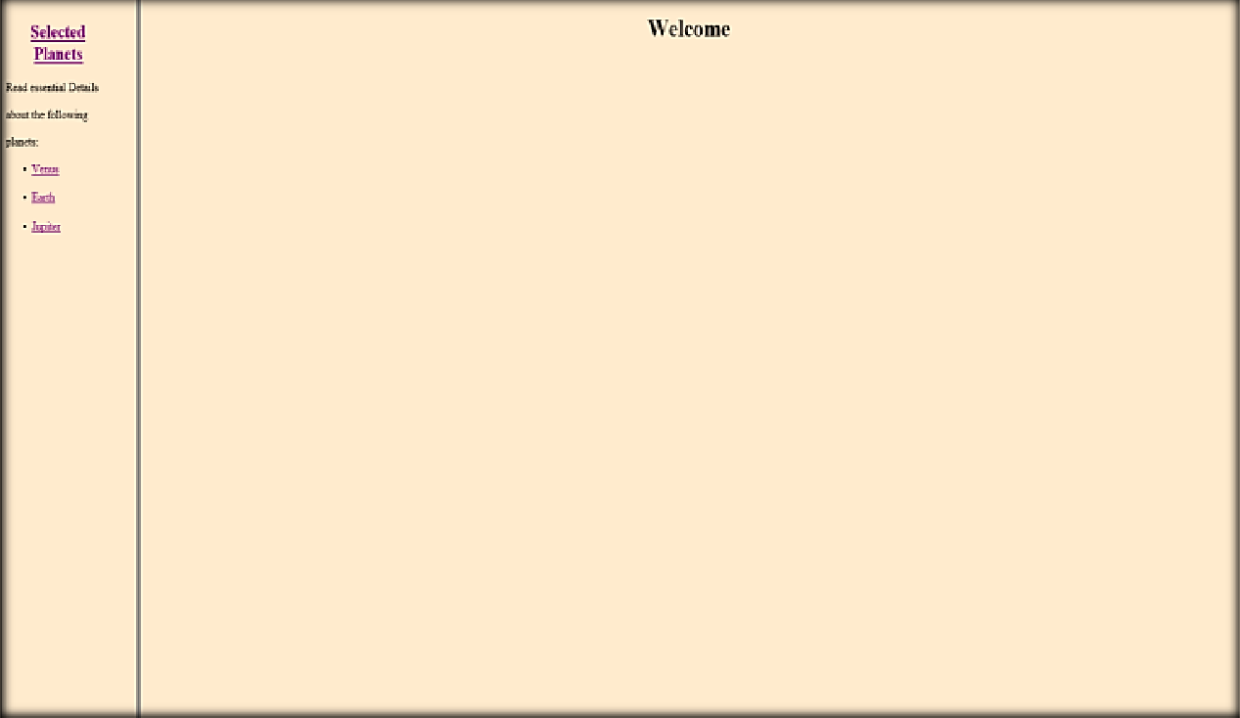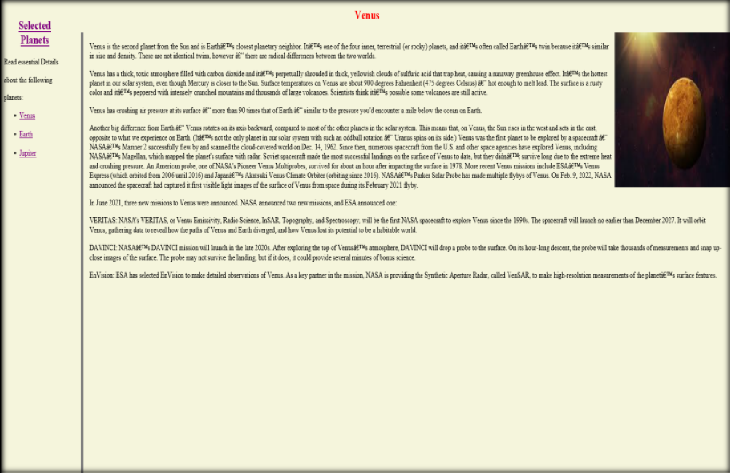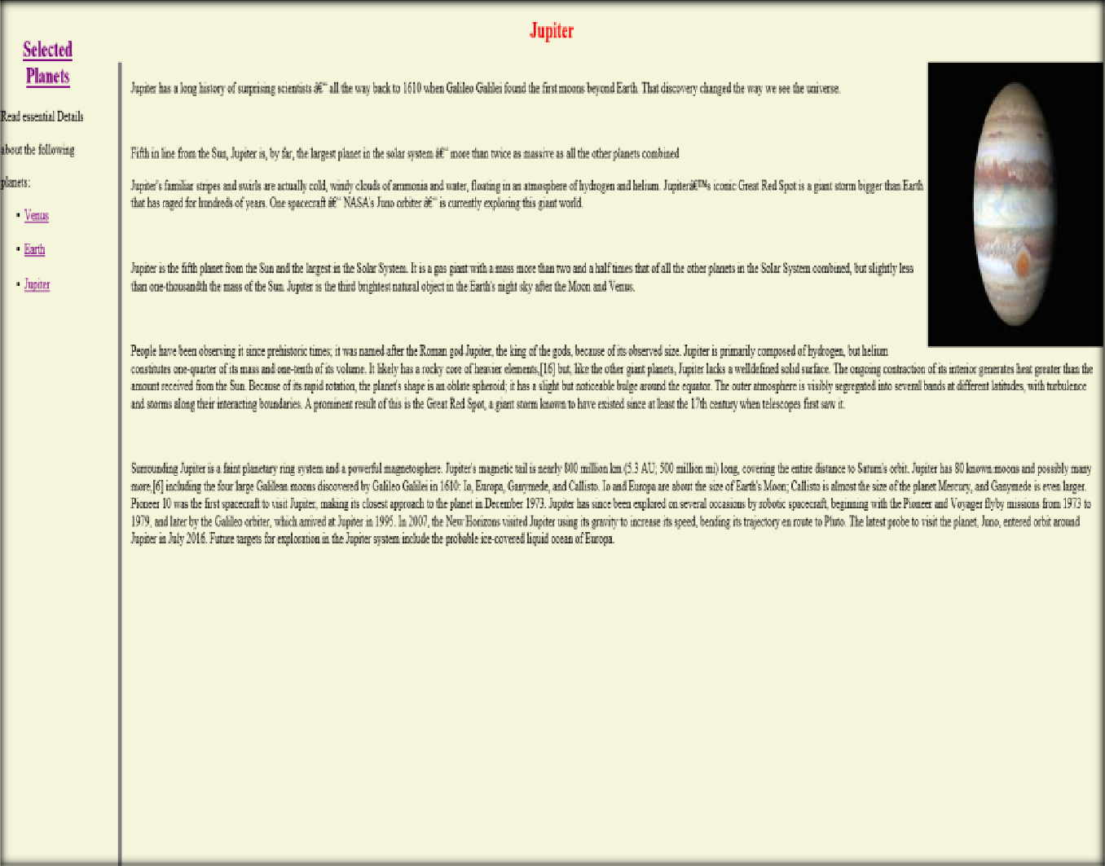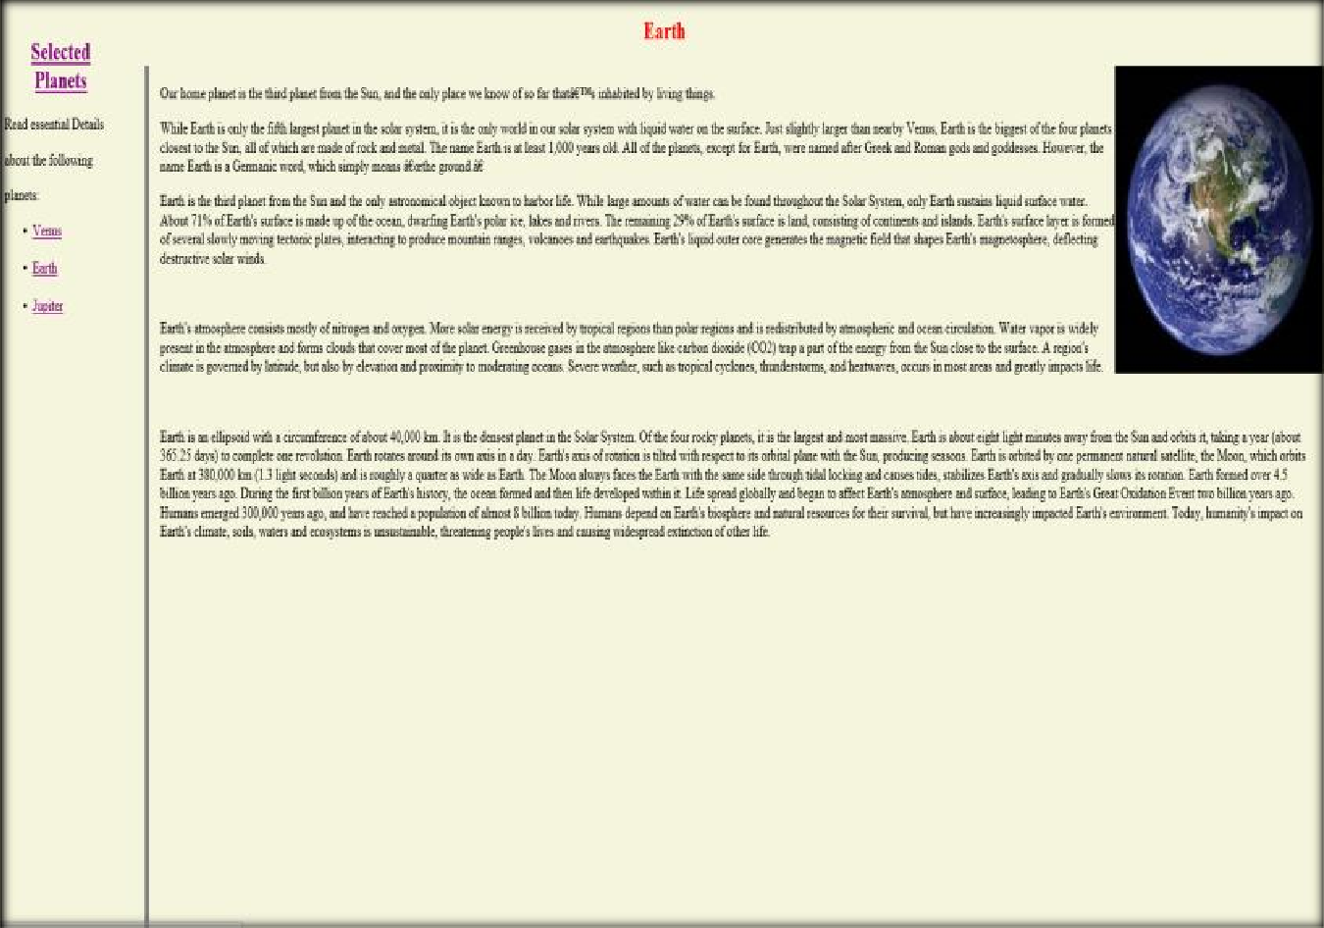

**Q-4: Write an HTML page that contains a selection box with a list of 5 countries, when the user selects a country, its capital should be printed next to the list; Add CSS to customize the properties of the font of the capital (color, bold and font size)**

**Solution:**

<html>

<head>

<title>capitals of countries</title>

<!—Priyank Gupta B. Tech CSE Section SE 2015092 -->

<style>

p {

color: red;

font-weight: bold;

font-size: 50;

}

</style>

<script language="javascript">

function capital() {

var cunt = document.forms["frm1"].country.value;

var capital = " Please select any country ";

if (cunt == "india") {

capital = "NEW DELHI";

}

if (cunt == "china") {

capital = "BEIJING";

}

if (cunt == "pakistan") {

capital = "ISLAMABAD";

}

if (cunt == "bangladesh") {

capital = "DHAKA";

}

if (cunt == "japan") {

capital = "TOKYO";

}

if (cunt == "select") {

capital = "Please select any country";

}

document.getElementById("capt").innerHTML = capital;

}

</script>

</head>

<body>

<form name="frm1">

<br />

<center>

Select a Country : <select name="country" onchange="capital()">

<option value="select">--SELECT--</option>

<option value="india">INDIA</option>

<option value="china">CHINA</option>

<option value="pakistan">PAKISTAN</option>

<option value="bangladesh">BANGLADESH</option>

<option value="japan">JAPAN</option>

</select>

<br />

<br />

<font color="green" size="6">Capital is :</font>

<p id="capt"></p>

</center>

</form>

</body>

</html>

**Output:**

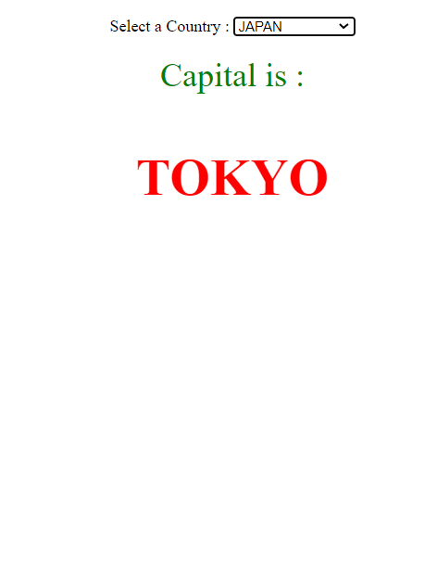

**Q-5. Develop and demonstrate the usage of inline, internal and external style sheet using CSS.**

**Solution:**

**Index.html**

<!DOCTYPE html>

<!—Priyank Gupta B. Tech CSE Section SE 2015092 -->

<head>

<meta name="viewport" content="width=device-width, initial-scale=1.0" />

<title>CSS internal,external and inline</title>

<link rel="stylesheet" href="style.css" />

<style>

body {

background-color: black;

}

.first {

background-color: pink;

height: 100px;

width: 100px;

}

</style>

</head>

<body>

<div class="first">BOX</div>

<div class="second">BOX</div>

<div style="background-color: green; height: 100px; width: 100px">BOX</div>

</body>

</html>

**Style.css**

.second{

background-color: yellow;

height:100px;

width:100px;

}

**Output: -**

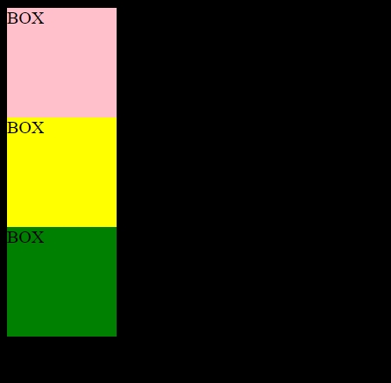

**Q-6. Create a student registration system page using HTML tags and apply box model using external CSS.**

**Solution:   
Index.html**

<!DOCTYPE html>

<head>

<!—Priyank Gupta B. Tech CSE Section SE 2015092 -->

<meta name="viewport" content="width=device-width, initial-scale=1.0">

<title>Student Registration Form</title>

<link rel="stylesheet" href="style.css">

</head>

<body>

<form class="signup-form" action="/register" method="post">

<div class="form-header">

<h1>Registration</h1>

</div>

<div class="form-body">

<div class="horizontal-group">

<div class="form-group left">

<label for="firstname" class="label-title">First name *</label>

<input type="text" id="firstname" class="form-input" placeholder="enter your first name" required="required" />

</div>

<div class="form-group right">

<label for="lastname" class="label-title">Last name</label>

<input type="text" id="lastname" class="form-input" placeholder="enter your last name" />

</div>

</div>

<div class="form-group">

<label for="email" class="label-title">Email*</label>

<input type="email" id="email" class="form-input" placeholder="enter your email" required="required">

</div>

<div class="horizontal-group">

<div class="form-group left">

<label for="password" class="label-title">Password *</label>

<input type="password" id="password" class="form-input" placeholder="enter your password" required="required">

</div>

<div class="form-group right">

<label for="confirm-password" class="label-title">Confirm Password *</label>

<input type="password" class="form-input" id="confirm-password" placeholder="enter your password again" required="required">

</div>

</div>

<div class="horizontal-group">

<div class="form-group left">

<label class="label-title">Gender:</label>

<div class="input-group">

<label for="male">

<input type="radio" name="gender" value="male" id="male"> Male</label>

<label for="female">

<input type="radio" name="gender" value="female" id="female"> Female</label>

</div>

</div>

<div class="form-group right">

<label class="label-title">Hobbies</label>

<div>

<label>

<input type="checkbox" value="Web">Music</label>

<label>

<input type="checkbox" value="iOS">Sports</label>

<label>

<input type="checkbox" value="Andriod">Travel</label>

<label>

<input type="checkbox" value="Game">Movies</label>

</div>

</div>

</div>

<div class="horizontal-group">

<div class="form-group left" >

<label class="label-title">Source of Income</label>

<select class="form-input" id="level" >

<option value="B">Employed</option>

<option value="I">Self-employed</option>

<option value="A">Unemployed</option>

</select>

</div>

<div class="form-group right">

<label for="experience" class="label-title">Income</label>

<input type="range" min="20" max="100" step="5" value="0" id="experience" class="form-input" onChange="change();" style="height:28px;width:78%;padding:0;">

<span id="range-label">20K</span>

</div>

</div>

<div class="horizontal-group">

<div class="form-group left" >

<label for="choose-file" class="label-title">Upload Profile Picture</label>

<input type="file" id="choose-file" size="80">

</div>

<div class="form-group right">

<label for="experience" class="label-title">Age</label>

<input type="number" min="18" max="80" value="18" class="form-input">

</div>

</div>

<div class="form-group">

<label for="choose-file" class="label-title">Bio</label>

<textarea class="form-input" rows="4" cols="50" style="height:auto"></textarea>

</div>

</div>

<!—Priyank Gupta B. Tech CSE Section SE 2015092 -->

<div class="form-footer">

<!-- form footer -->

<div class="form-footer">

<span>* required</span>

<button type="submit" class="btn">Create</button>

</div>

</div>

</form>

<script>

var rangeLabel = document.getElementById("range-label");

var experience = document.getElementById("experience");

function change() {

rangeLabel.innerText = experience.value + "K";

}

</script>

</body>

</html>

**Style.css**

@import url('httpss://fonts.googleapis.com/css?family=Roboto');

body {

background:linear-gradient(to right, #78a7ba 0%, #385D6C 50%, #78a7ba 99%);

}

.signup-form {

font-family: "Roboto", sans-serif;

width:650px;

margin:30px auto;

background:linear-gradient(to right, #ffffff 0%, #fafafa 50%, #ffffff 99%);

border-radius: 10px;

}

.form-header {

background-color: #EFF0F1;

border-top-left-radius: 10px;

border-top-right-radius: 10px;

}

<!—Priyank Gupta B. Tech CSE Section SE 2015092 -->

.form-header h1 {

font-size: 30px;

text-align:center;

color:#666;

padding:20px 0;

border-bottom:1px solid #cccccc;

}

.form-body {

padding:10px 40px;

color:#666;

}

.form-group{

margin-bottom:20px;

}

.form-body .label-title {

color:#1BBA93;

font-size: 17px;

font-weight: bold;

}

.form-body .form-input {

font-size: 17px;

box-sizing: border-box;

width: 100%;

height: 34px;

padding-left: 10px;

padding-right: 10px;

color: #333333;

text-align: left;

border: 1px solid #d6d6d6;

border-radius: 4px;

background: white;

outline: none;

}

.horizontal-group .left{

float:left;

width:49%;

}

.horizontal-group .right{

float:right;

width:49%;

}

input[type="file"] {

outline: none;

cursor:pointer;

font-size: 17px;

}

#range-label {

width:15%;

padding:5px;

background-color: #1BBA93;

color:white;

border-radius: 5px;

font-size: 17px;

position: relative;

top:-8px;

}

::-webkit-input-placeholder {

color:#d9d9d9;

}

.form-footer {

clear:both;

}

.signup-form .form-footer {

background-color: #EFF0F1;

border-bottom-left-radius: 10px;

border-bottom-right-radius: 10px;

padding:10px 40px;

text-align: right;

border-top: 1px solid #cccccc;

}

.form-footer span {

float:left;

margin-top: 10px;

color:#999;

font-style: italic;

font-weight: thin;

}

.btn {

display:inline-block;

padding:10px 20px;

background-color: #1BBA93;

font-size:17px;

border:none;

border-radius:5px;

color:#bcf5e7;

cursor:pointer;

}

.btn:hover {

background-color: #169c7b;

color:white;

}

**Output:**

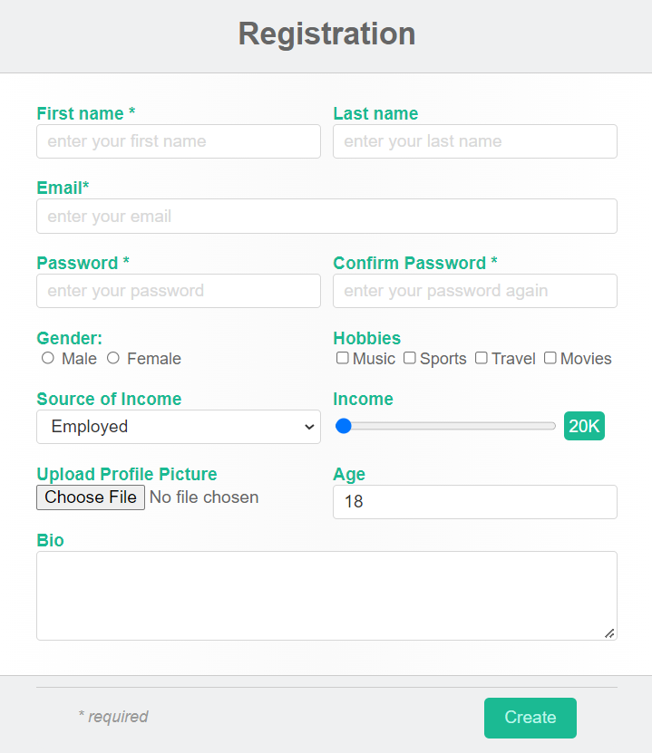

**Q-7 -A. Write a JavaScript program to test the first character of a string is uppercase or not.**

**Solution:**

function upper_case(str)

{

regexp = /^[A-Z]/;

if (regexp.test(str))

{

console.log("String's first character is uppercase");

}

else

{

console.log("String's first character is not uppercase");

}

}

<!—Priyank Gupta B. Tech CSE Section SE 2015092 -->

upper_case('Abcd');

upper_case('abcd');

**Q-7 B. Write a JavaScript code to take color from user and apply that color to Div tag.**

**Solution:**

<html>

<head>

<style>

#Myelement {

width: 500px;

height: 100px;

}

</style>

</head>

<body>

<!—Priyank Gupta B. Tech CSE Section SE 2015092 -->

<div id="Myelement"

onclick="changeColor()">

</div>

<input name="MyColorPicker"

type="color"

id="MyColorPicker" />

</body>

</html>

<script>

function changeColor() {

document.getElementById(

"Myelement").style.backgroundColor =

document.getElementById(

"MyColorPicker").value;

}

</script>

**Output: -**



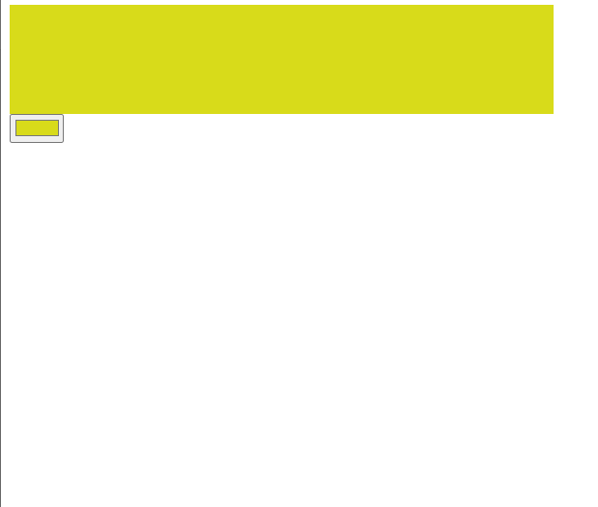

**Q-8. Write JavaScript to validate the following fields of the Registration page. 1. First Name (Name should be min 4 characters and max 8 characters) 2. Password & Confirm Password (Password should not be less than 8 characters length). 3. Email id (should not contain any invalid mail) 4. Mobile Number (Phone number should be 8 digits only) 5. Last Name and Address (should not be Empty).**

**Solution:**

**Index.html**

<html>

<head>

<style>

<!—Priyank Gupta B. Tech CSE Section SE 2015092 -->

.content

{

padding: 50px;

margin-left: 25%;

}

input

{

padding: 10px;

}

</style>

</head>

<body>

<h1 class="abhi">Login</h1>

<div class="content">

<label for="name">Full Name:</label>

<input type="text" onblur="nameCheck()" value="" id="fname"><br>

<label for="name">Password:</label>

<input type="password" onblur="passCheck()" value="" id="pass"><br>

<label for="name"> Confirm Password:</label>

<input type="password" onblur="conPassCheck()" value="" id="cpass"> <br>

<label for="name">E-mail</label>

<input type="email" onblur="eCheck()" value="" id="mail"><br>

<label for="mob">Mobile:</label>

<input type="text" onblur="mCheck()" value="" id="phone"> <br>

<label for="lname">Last Name:</label>

<input type="text" onblur="lnCheck()" value="" id="lname"><br>

<label for="Address">Address:</label>

<input type="text" onblur="addCheck()" value="" id="add">

</div>

</body>

<script src="app.js"></script>

</html>

**App.js**

<!—Priyank Gupta B. Tech CSE Section SE 2015092 -->

function nameCheck() {

var x = document.getElementById("fname");

if (!(x.value.length >= 4 && x.value.length <= 8)) {

alert("Name should be at least 4 char and max 8 char long");

x.value="";

}

}

function passCheck() {

var paswd = /^(?=.*[0-9])(?=.*[!@#$%^&*])[a-zA-Z0-9!@#$%^&*]{8,}$/;

var x = document.getElementById("pass");

if (!(x.value.match(paswd))) {

alert("Enter Valid password");

}

}

function conPassCheck() {

var x = document.getElementById("pass");

var y = document.getElementById("cpass");

if (!(x.value==y.value)) {

alert("Confirm password should be same as the password");

}

}

function eCheck() {

var email = document.getElementById("pass");

if(email.value=="")

{

alert('Please fill this field');

}

var filter = /^([a-zA-Z0-9_\.\-])+\@(([a-zA-Z0-9\-])+\.)+([a-zA-Z0-9]{2,4})+$/;

if (!filter.test(email.value)) {

alert("Please provide a valid email address");

}

}

function mCheck() {

var x = document.getElementById("phone");

if (!(x.value.length == 8)) {

alert("Phone Number should be 8 char long");

}

}

function lnCheck() {

var x = document.getElementById("lname");

if (x.value == "") {

alert("Please fill this field");

}

}

function addCheck() {

var x = document.getElementById("add");

if (x.value == "") {

alert("Please fill this field");

}

}

**Output: -**

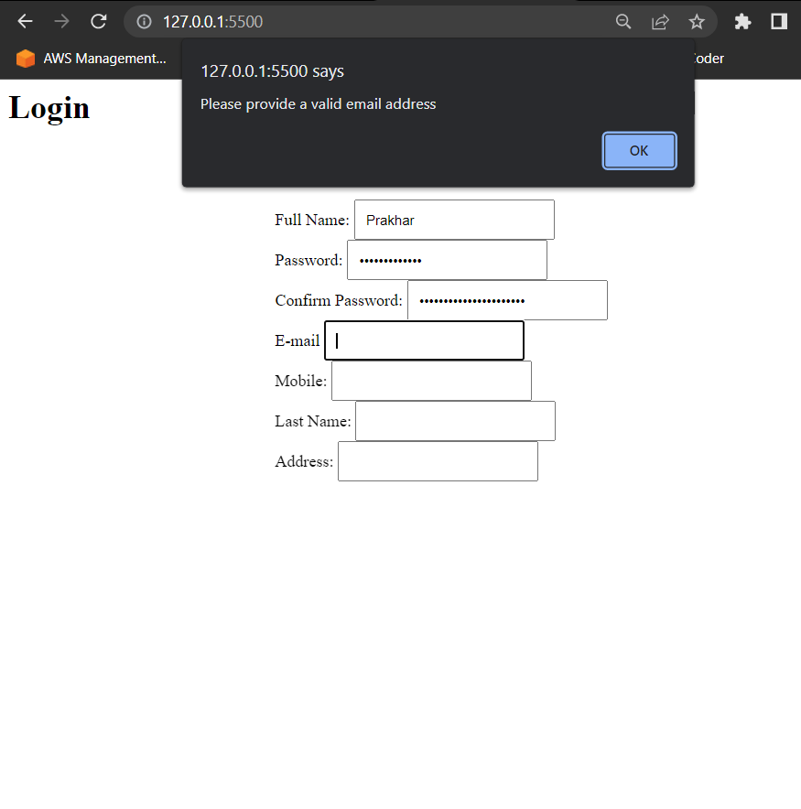

**Q-9. Create a HTML form and write JavaScript to generate the invoice with one click of GENERATE INVOICE button. Take any 5 product with rate and quantity and display total for every product. Calculate Grand Total by including 18% GST.**

**Solution:**

<!DOCTYPE html>

<head>

<!—Priyank Gupta B. Tech CSE Section SE 2015092 -->

<meta name="viewport" content="width=device-width, initial-scale=1.0">

<title>Document</title>

<style>

table{

border: 2px solid black;

border-collapse: collapse;

}

input{

margin: 5px;

}

th,td{

border-bottom: 1px solid black;

}

</style>

</head>

<body>

<table>

<tr>

<th>particulars</th>

<th>rate</th>

<th>quantity</th>

<th>total</th>

</tr><tr>

<td>Product 1</td>

<td><input type="text" id="rate1"></td>

<td><input type="text" id="quantity1"></td>

<td><input type="text" id="total1"></td>

</tr><tr>

<td>Product 2</td>

<td><input type="text" id="rate2"></td>

<td><input type="text" id="quantity2"></td>

<td><input type="text" id="total2"></td>

</tr><tr>

<td>Product 3</td>

<td><input type="text" id="rate3"></td>

<td><input type="text" id="quantity3"></td>

<td><input type="text" id="total3"></td>

</tr><tr>

<td>Product 4</td>

<td><input type="text" id="rate4"></td>

<td><input type="text" id="quantity4"></td>

<td><input type="text" id="total4"></td>

</tr><tr><!—Priyank Gupta B. Tech CSE Section SE 2015092 -->

<td>Product 5</td>

<td><input type="text" id="rate5"></td>

<td><input type="text" id="quantity5"></td>

<td><input type="text" id="total5"></td>

</tr><tr>

<td colspan="4" style="text-align:center"> Tax : <input type="text" id="tax"> Based on a 18% GST</td>

</tr><tr>

<td colspan="4" style="text-align:center"> Grandtotal : <input type="text" id="grandtotal"> Vat included</td>

</tr>

</table>

<script>

let total1 = document.getElementById('total1');

let total2 = document.getElementById('total2');

let total3 = document.getElementById('total3');

let total4 = document.getElementById('total4');

let total5 = document.getElementById('total5');

let p1total = 0;

let p2total = 0;

let p3total = 0;

let p4total = 0;

let p5total = 0;

total1.addEventListener('click', function fun() {

let rate1 =parseInt(document.getElementById('rate1').value);

let quantity1 = parseInt(document.getElementById('quantity1').value);

p1total = rate1 * quantity1;

total1.value = p1total;

});

total2.addEventListener('click', function fun() {

let rate2 = parseInt(document.getElementById('rate2').value);

let quantity2 = parseInt(document.getElementById('quantity2').value);

p2total = rate2 * quantity2;

total2.value = p2total;

});

total3.addEventListener('click', function fun() {

let rate3 = parseInt(document.getElementById('rate3').value);

let quantity3 = parseInt(document.getElementById('quantity3').value);

p3total = rate3 * quantity3;

total3.value = p3total;

});

total4.addEventListener('click', function fun() {

let rate4 = parseInt(document.getElementById('rate4').value);

let quantity4 = parseInt(document.getElementById('quantity4').value);

p4total = rate4 * quantity4;

total4.value = p4total;

});

total5.addEventListener('click', function fun() {

let rate5 = parseInt(document.getElementById('rate5').value);

let quantity5 = parseInt(document.getElementById('quantity5').value);

p5total = rate5 * quantity5;

total5.value = p5total;

});<!—Priyank Gupta B. Tech CSE Section SE 2015092 -->

let tax = 0;

let taxinpt = document.getElementById('tax');

taxinpt.addEventListener('click', ()=>{

tax = (p1total+p2total+p3total+p4total+p5total)*0.18;

taxinpt.value = tax;

});

let gt = document.getElementById('grandtotal');

gt.addEventListener('click', ()=>{

gt.value = p1total+p2total+p3total+p4total+p5total+tax;

})

</script>

</body>

</html>

**Output: -**

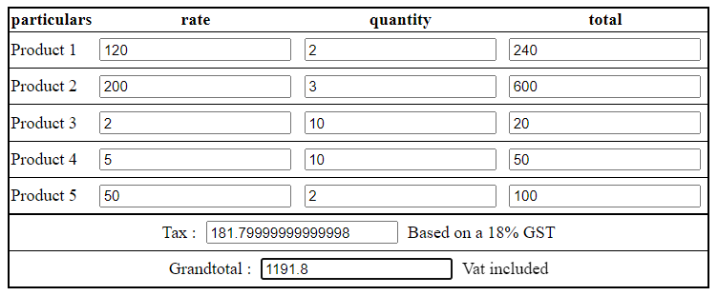

**Q-10 A.Write a JQuery code to give animation to div on click of button.**

**Solution:**

<!DOCTYPE html>

<html>

<!—Priyank Gupta B. Tech CSE Section SE 2015092 -->

<head>

<script src="https://ajax.googleapis.com/ajax/libs/jquery/3.6.0/jquery.min.js"></script>

<script>

$(document).ready(function(){

$("button").click(function(){

$("div").animate({

left: '250px',

opacity: '0.5',

height: '150px',

width: '150px'

});

});

});

</script>

</head>

<body>

<button>Start Animation</button>

<div style="background:RED;height:100px;width:100px;position:absolute;"></div>

</body>

</html>

**Output: -**

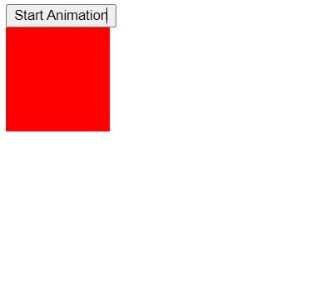

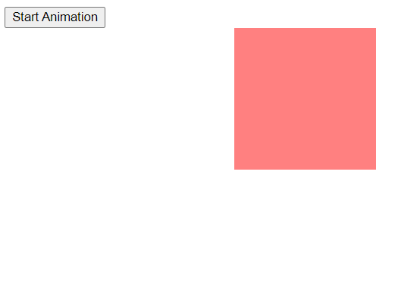

**Q-10 B.Write a JQuery code to add dynamic element on page on click of button.**

**Solution:**

<!—Priyank Gupta B. Tech CSE Section SE 2015092 -->

<head>

<meta charset="utf-8">

<title>jQuery Bind Click Event to Dynamically added Elements</title>

<script src="https://code.jquery.com/jquery-3.5.1.min.js"></script>

<script>

$(document).ready(function () {

$("button").click(function () {

$("ol").append("<li>Button <a href='javascript:void(0);' class='remove'>&times;</a></li>");

});

$(document).on("click", "a.remove", function () {

$(this).parent().remove();

});

});

</script>

</head>

<body>

<button>Add Button</button>

<p>Click the above button to add button. <p>

<ol>

<li>Button</li><li>Button</li><li>Button</li>

</ol>

</body>

</html>

**Output:**

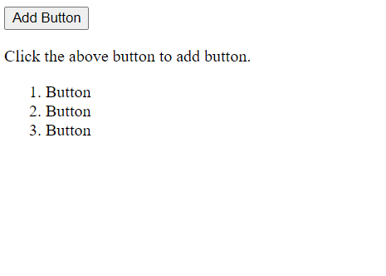

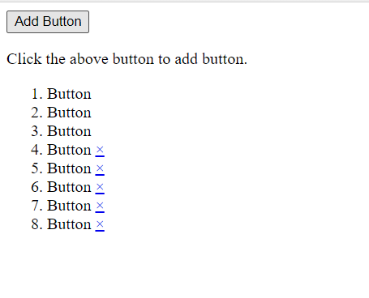

**Q-11. Write a jQuery program to demonstrate the use of mouse event, keyboard event and form event.**

**Solution:**

<!DOCTYPE html>

<head><!—Priyank Gupta B. Tech CSE Section SE 2015092 -->

<meta name="viewport" content="width=device-width, initial-scale=1.0">

<title>Program 11</title>

<script src="https://ajax.googleapis.com/ajax/libs/jquery/3.6.0/jquery.min.js"></script>

<script>

let i = 0;

$(document).ready(function () {

//Mouse Event

$("p").click(function () {

$(this).hide();

})

$("#p1").hover(function () {

alert("You entered p1!");

},

function () {

alert("Bye! You now leave p1!");

})

//Keyboard event

$("input").keypress(function () {

$("span").text(i += 1);

});

//Form event

$("#target").blur(function () {

alert("Handler for .blur() called.");

});

});

</script>

</head>

<body>

<p>Click me first</p>

<p>Click me second</p>

<p id="p1" style="display: inline; border: 2px solid red">This is text</p><br><br>

Enter your name: <input type="text">

<p>Keypresses: <span>0</span></p>

<form>

<input id="target" type="text" value="Field 1">

</form>

</body>

</html>

**Output: -**

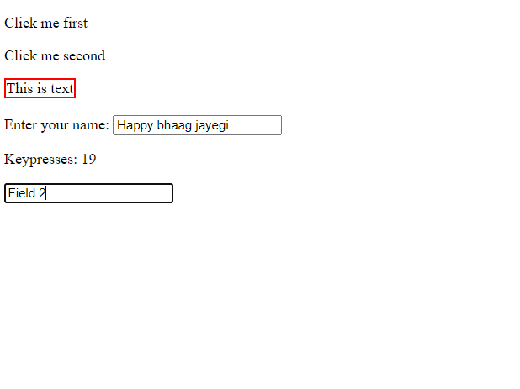

**Q-12. Write a jQuery program to demonstrate the use of display effect, fade effect and slide effect.**

**Solution:**

<!DOCTYPE html>

<html>

<!—Priyank Gupta B. Tech CSE Section SE 2015092 -->

<head>

<script src="https://ajax.googleapis.com/ajax/libs/jquery/3.6.0/jquery.min.js"></script>

<script>

$(document).ready(function () {

//Display Effect

$(".btn1").click(function () {

$("p").hide();

});

$(".btn2").click(function () {

$("p").show();

});

//Fade Effect

$("button").click(function () {

$("#div1").fadeToggle();

$("#div2").fadeToggle("slow");

$("#div3").fadeToggle(3000);

})

//Side Effect

$("#flip").click(function () {

$("#panel").slideToggle("slow");

});

});

</script>

<style>

#panel,

#flip {

padding: 5px;

text-align: center;

width: 50%;

background-color: rgb(83, 219, 83);

border: solid 1px #c3c3c3;

margin: auto;

}

#panel {

padding: 50px;

display: none;

}

</style>

</head>

<body>

<p>This is a paragraph.</p>

<button class="btn1">Hide</button>

<button class="btn2">Show</button>

<br><br>

<button>Click to fade in/out boxes</button><br><br>

<div id="div1" style="width:80px;height:80px;background-color:red;"></div>

<br>

<div id="div2" style="width:80px;height:80px;background-color:green;"></div>

<br><!—Priyank Gupta B. Tech CSE Section SE 2015092 -->

<div id="div3" style="width:80px;height:80px;background-color:blue;"></div>

<br><br>

<div id="flip">Click to slide the panel down or up</div>

<div id="panel">Hello world!</div>

</body>

</html>

**Output: -**

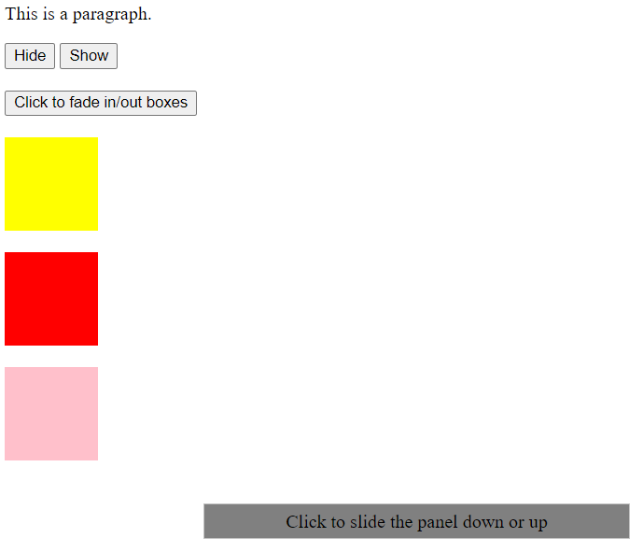

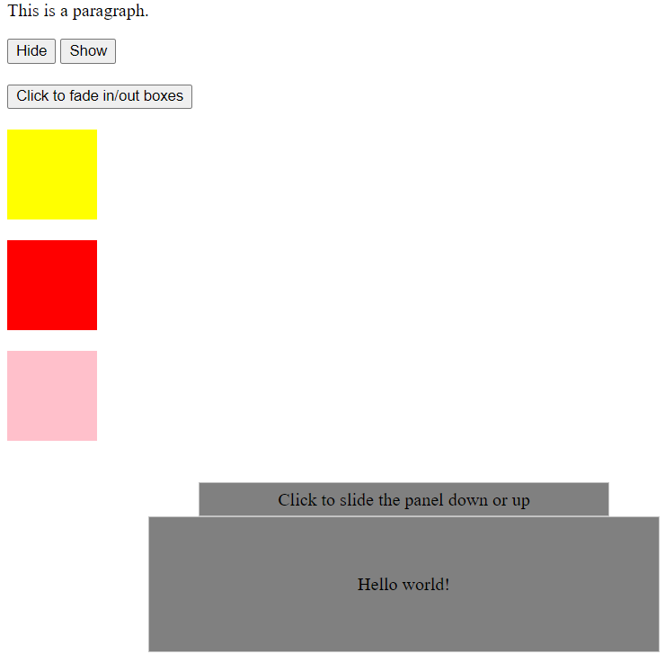

**Q- 13.A simple calculator web application that takes two numbers and an operator (+, -, /,*and %) from an HTML page and returns the result page with the operation performed on the operands.**

**Solution:**

<!DOCTYPE html>

<html lang="en">

<head><!—Priyank Gupta B. Tech CSE Section SE 2015092 -->

<meta charset="UTF-8">

<meta http-equiv="X-UA-Compatible" content="IE=edge">

<meta name="viewport" content="width=device-width, initial-scale=1.0">

<title>Document</title>

</head>

<body>

<form>

<label for="num1">Number1</label>

<input type="number" id="num1" name="num1"><br>

<label for="num2">Number2</label>

<input type="number" id="num2" name="num2"><br>

<br>

<label for="opr">Choose Operation : </label>

<select name="opr" id="opr">

<option value="add">Add</option>

<option value="sub">Subtract</option>

<option value="div">Divide</option>

<option value="mul">Multiply</option>

</select>

<br>

<input type="button" onClick="submit()" id="submit" value="Submit"><br>

<p>Result : </p>

<p id="res"></p>

</form>

<script>

but = document.getElementById('submit');

but.addEventListener("click" , function()

{

num1 = parseInt(document.getElementById("num1").value);

num2 = parseInt(document.getElementById("num2").value)

opr = document.getElementById('opr');

select = opr.options[opr.selectedIndex].value;

if(select == 'add')

{

cal = num1+num2;

document.getElementById('res').innerHTML = cal;

}

else if(select == 'sub')

{

cal = num1-num2;

document.getElementById('res').innerHTML = cal;

}

else if(select == 'div')

{

cal = num1/num2;

document.getElementById('res').innerHTML = cal;

}

else if(select == 'mul')

{

cal = num1*num2;

document.getElementById('res').innerHTML = cal;

}

});<!—Priyank Gupta B. Tech CSE Section SE 2015092 -->

</script>

</body>

</html>

**Output:**

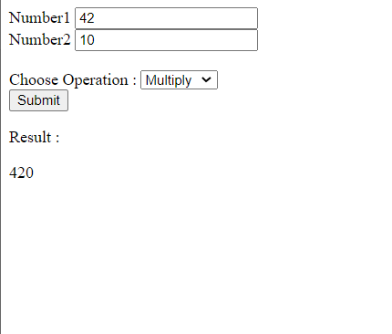

**Q-14. Write PHP program for student registration. Perform insert, display, update and delete operations from database. (use any database).**

**Solution:**

**_db_connect.php**

<?php

<!—Priyank Gupta B. Tech CSE Section SE 2015092 -->

$server = "localhost ";

$username = 'root';

$password = '';

$database = "student";

$conn = mysqli_connect($server, $username, $password, $database);

if(!$conn)

die("Error " . mysqli_connect_error());

else

echo 'Connection made successfully!!'

?>

**Output: -**

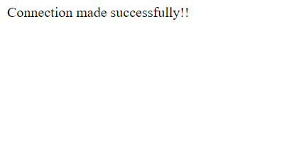

**welcome.php**

<!DOCTYPE html>

<html lang="en">

<head>

<!—Priyank Gupta B. Tech CSE Section SE 2015092 -->

<meta charset="UTF-8">

<meta http-equiv="X-UA-Compatible" content="IE=edge">

<meta name="viewport" content="width=device-width, initial-scale=1.0">

<title>Welcome</title>

<style>

div{

display: flex;

justify-content: center;

align-items: center;

margin-top: 210px;

}

li{

font-size:30px;

}

</style>

</head>

<body>

<div>

<ul>

<li><a class="nav-link" href="insert.php">Insert</a></li>

<li><a class="nav-link" href="display.php">Display</a></li>

<li><a class="nav-link" href="update.php">Update</a></li>

<li><a class="nav-link" href="delete.php">Delete</a></li>

</ul>

</div>

</body>

</html>

**Output:**

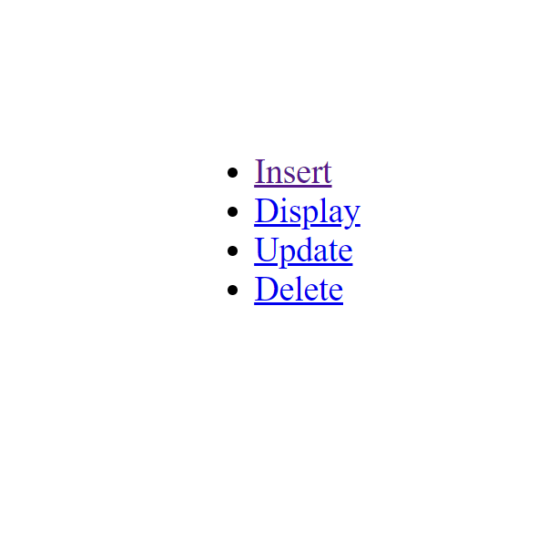

**insert.php**

<?php

<!—Priyank Gupta B. Tech CSE Section SE 2015092 -->

if($_SERVER['REQUEST_METHOD'] == 'POST') {

$name = $_POST['name'];

$email = $_POST['email'];

$gender = $_POST['gender'];

if($gender == 'male') {

$gender = 'm';

}else $gender = 'f';

require 'partials/_db_connect.php';

$sql = "INSERT INTO student(`name`, `email`, `gender`) values('$name', '$email', '$gender')";

$result = mysqli_query($conn, $sql);

if($result) {

echo "<script>

alert('Regitration Successful');

</script>";

}else {

echo "<script>

alert('Not Registered');

</script>";

}

}

?>

<!DOCTYPE html>

<html lang="en">

<head>

<meta charset="UTF-8">

<meta http-equiv="X-UA-Compatible" content="IE=edge">

<meta name="viewport" content="width=device-width, initial-scale=1.0">

<title>Insert</title>

<style>

#container{

display: flex;

justify-content: center;

align-items: center;

margin-top:210px;

}

a{

font-size:25px;

}

</style>

</head>

<body>

<h2>

<a href="/anant/registration/Welcome.php">Home</a>

</h2>

<div id="container">

<form action="insert.php" method="post"><!—Priyank Gupta B. Tech CSE Section SE 2015092 -->

<label for="name">Name : </label>

<input type="text" name="name" id="name"><br><br>

<label for="email">Email : </label>

<input type="email" name="email" id="email">

<h3>Gender</h3>

<input type="radio" name="gender" id="male" value="male">

<label for="male">Male</label>

<input type="radio" name="gender" id="female" value="female">

<label for="female">Female</label><br><br>

<button type="submit" id="btn">Submit</button>

</form>

</div>

</body>

</html>

**Output:**

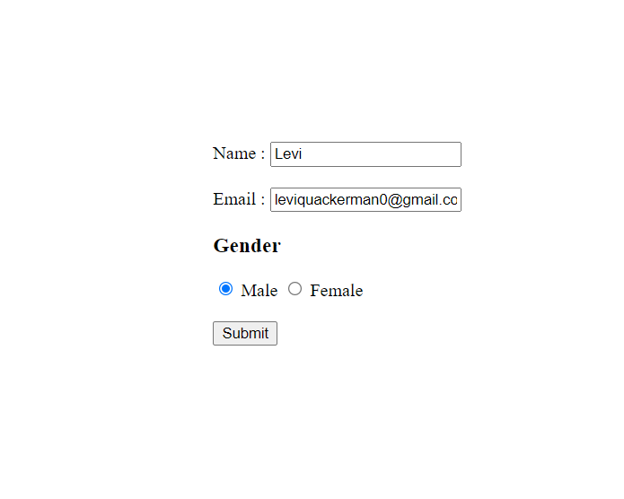

**display.php**

<?php

echo '<title>Display</title>';

echo '

<h2><!—Priyank Gupta B. Tech CSE Section SE 2015092 -->

<a style="font-size:25px;" href="/anant/registration/Welcome.php">Home</a>

</h2>';

require 'partials/_db_connect.php';

$sql = 'SELECT * FROM student';

$result = mysqli_query($conn, $sql);

if($result) {

$num = mysqli_num_rows($result);

if($num > 0) {

echo '<table border="2" cellspacing="3" cellpadding="2">

<tr>

<th>Name</td>

<th>Email</td>

<th>Gender</td>

</tr>';

while($row = mysqli_fetch_assoc($result)) {

$gen = "Male";

if($row['gender'] == 'f') $gen = 'Female';

echo

'<tr>

<td>'.$row['name'].'</td>

<td>'.$row['email'].'</td>

<td>'.$gen.'</td>

</tr>';

}

echo '</table>';

}

}

?>

**Output: -**

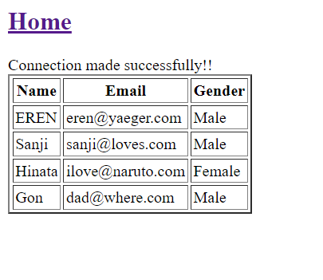

**update.php**

<?php

if($_SERVER['REQUEST_METHOD'] == 'POST') {

$name = $_POST['name']; <!—Priyank Gupta B. Tech CSE Section SE 2015092 -->

$email = $_POST['email'];

require 'partials/_db_connect.php';

$sql = "update student set `email` = '$email' where `name` = '$name'";

$result = mysqli_query($conn, $sql);

if($result) {

echo "<script>

alert('Updation Successful');

</script>";

}else {

echo "<script>

alert('User Not Found');

</script>";

}

}

?>

<!DOCTYPE html>

<html lang="en">

<head>

<meta charset="UTF-8">

<meta http-equiv="X-UA-Compatible" content="IE=edge">

<meta name="viewport" content="width=device-width, initial-scale=1.0">

<title>Update</title>

<style>

a{

font-size:25px;

}

</style>

</head>

<body>

<h2>

<a href="/anant/registration/Welcome.php">Home</a>

</h2>

<form action="update.php" method="post">

<label for="name">Name:</label>

<input type="text" placeholder="Enter Name" name="name"><br><br>

<label for="email">Enter your New Email:</label>

<input type="email" placeholder="Enter new Email" name="email">

<button type="submit">Update</button>

</form>

</body>

</html>

**Output:**

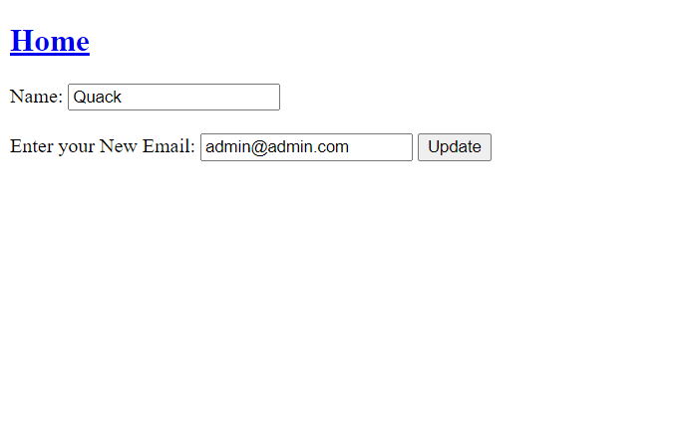

**delete.php**

<?php

if($_SERVER['REQUEST_METHOD'] == 'POST') {

$name = $_POST['name']; <!—Priyank Gupta B. Tech CSE Section SE 2015092 -->

require 'partials/_db_connect.php';

$sql = "delete from `student` where `name`='$name'";

$result = mysqli_query($conn, $sql);

if($result) {

echo "<script>

alert('Deletion Successful');

</script>";

}else {

echo "<script>

alert('User Not Found');

</script>";

}

}

?>

<!DOCTYPE html>

<html lang="en">

<head>

<meta charset="UTF-8">

<meta http-equiv="X-UA-Compatible" content="IE=edge">

<meta name="viewport" content="width=device-width, initial-scale=1.0">

<title>Delete</title>

<style>

a{

font-size:25px;

}

</style>

</head>

<body>

<h2>

<a href="/anant/registration/Welcome.php">Home</a>

</h2>

<form action="delete.php" method="post">

<label for="name">Name:</label>

<input type="text" placeholder="Enter Name" name="name">

<button type="submit">Delete</button>

</form>

</body>

</html>

**Output:**

**Before deletion: - Deletion command: - After deletion: -**

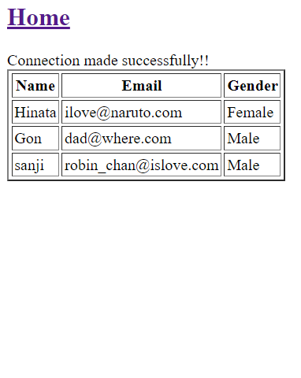 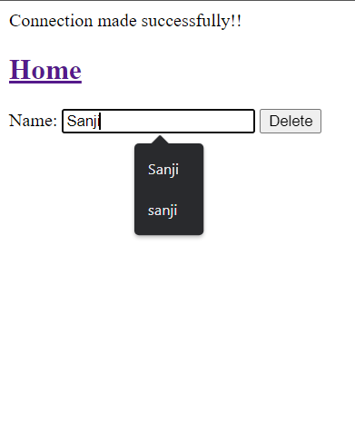 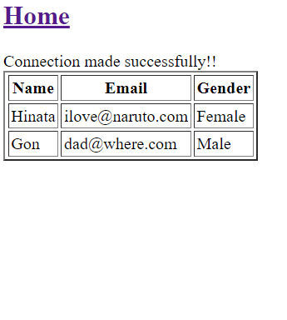

**Q-15. Write a PHP program to store current date-time in a COOKIE and display the ‘Last visited on’ date-time on the web page upon reopening of the same page.**

**Solution:**

<?php

// time for 60 days in future

$cookie_value = time() + 60*60*60*24;

<!—Priyank Gupta B. Tech CSE Section SE 2015092 -->

setcookie('lastvisit' , date("G:i , m/d/y") , $cookie_value , )

?>

<?php

if(isset($_COOKIE['lastvisit']))

{

echo "Your last visit time and date are : " . $_COOKIE['lastvisit'] . "<br>";

setcookie('lastvisit',"",time()-3600);

}

else{

echo "This is your first visit <br>";

}

?>

**Output:**

